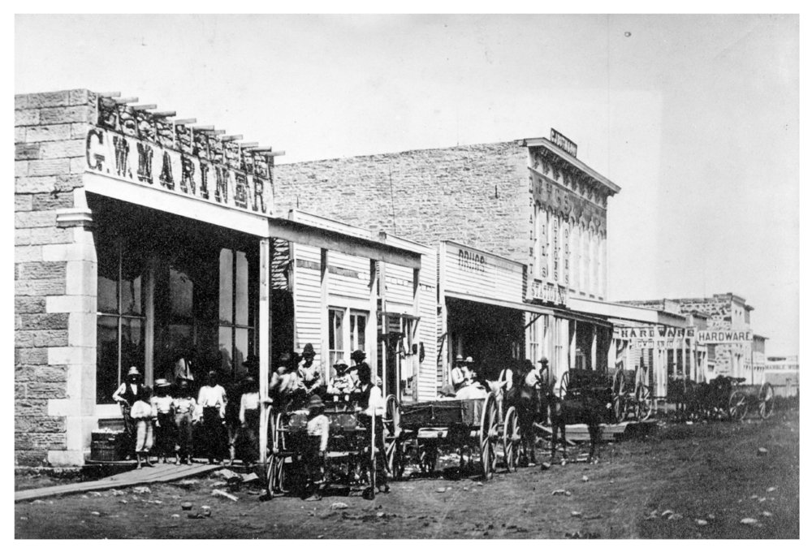
History Camp
REGISTRATION FORM
"Pioneers Become Settlers: Fredonia at the Turn of the Century"
June 10-14, 2024 9 a.m. – 11:30 a.m.

Camp will be held at: Rollin ‘Red’ Vandever Memorial Park,
Home of the Old Iron Club, 10392 Jade Rd, Fredonia, KS

$20 for the 5-day camp – snacks and all supplies provided

Enrollment is limited – Return your forms promptly Enrollment & pre-payment deadline is Friday, May 17

Instructors include Mike & Deb Myers, Leanne Githens, and Stacy Siegele

Student’s Name _________________________________________________ Grade Fall, 2024: (circle one) Grade 4 / 5 / 6

Parent Name: __________________________________________________

Address: ______________________________________________________

City, State & Zip: _________________________________________________________________

Phone number: ____________ / ____________ / ____________

Email Address for final instructions: __________________________________________________

Emergency contact cell phone number: ____________ / ____________ / ____________

Does the participant have any medical condition/allergies the instructors should be aware? (ie: diabetes, asthma, seizures, etc.)?

Circle: Yes / No. If yes, explain: _________________________________________________________________________________

Please register for camp only if you know your child can attend all 5 days. There will be no refunds for missed days.

=======================================================
PERMISSION:
My child has permission to participate fully in all planned History camp activities, including an excursion to downtown Fredonia, being transported by van or private vehicle. I will drop him/her off promptly prior to 9 am. And pick him/her up at 11:30 a.m.

Parent/Guardian Signature ___________________________________________________ Date ________________________
For more information, Contact us at the Museum at: 620-378-3965
Or wilcohisoc@twinmounds.com

Payment date: _____ / _____ / _____ Cash or Check # ___________

History Camp is sponsored by the Wilson Co. Historical Museum
$20 Registration Fee Must be Paid in Advance to Secure Registration.
Return registration form to the Museum, 420 N 7th, Fredonia, KS

